- If Engineering has responded with comments, Email alert will go to Buyer against that Receipt the buyer has to login to his session to upload the Comments on Pre Order Portal.
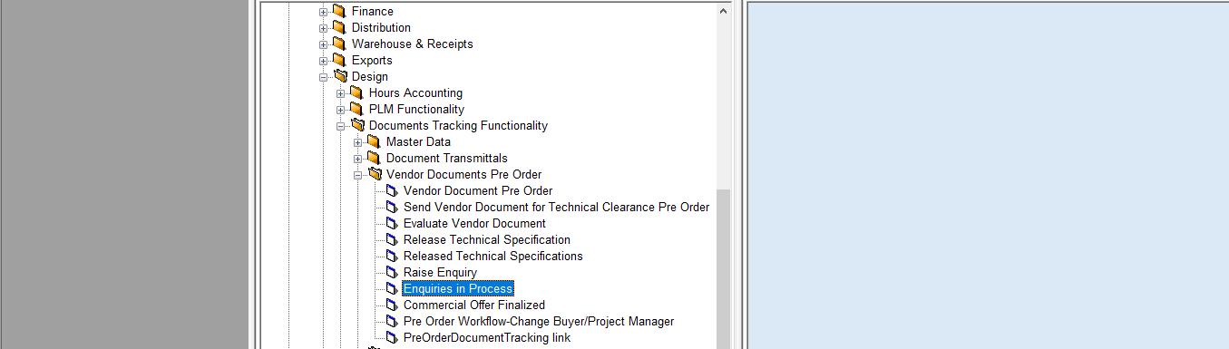
Enquiry in Process

- In The Screen that opens up click on View Enquiry.
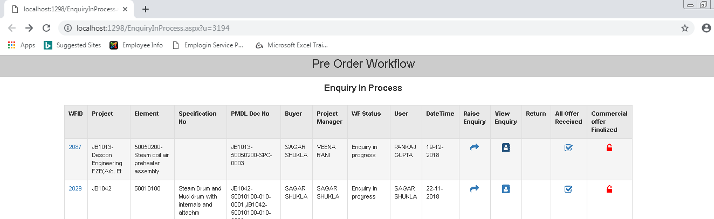
View Enquiry

- Select WFID.
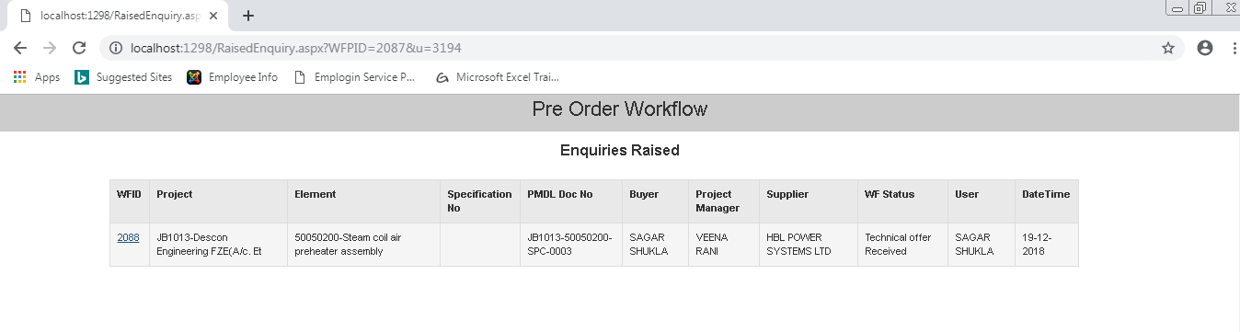
WFID

- Click on Notes Option in the screen that opens up
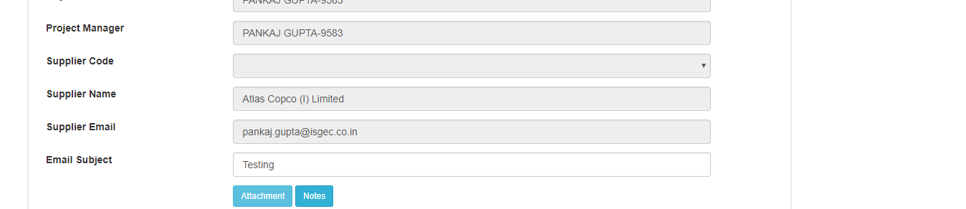

- Click on attachment .
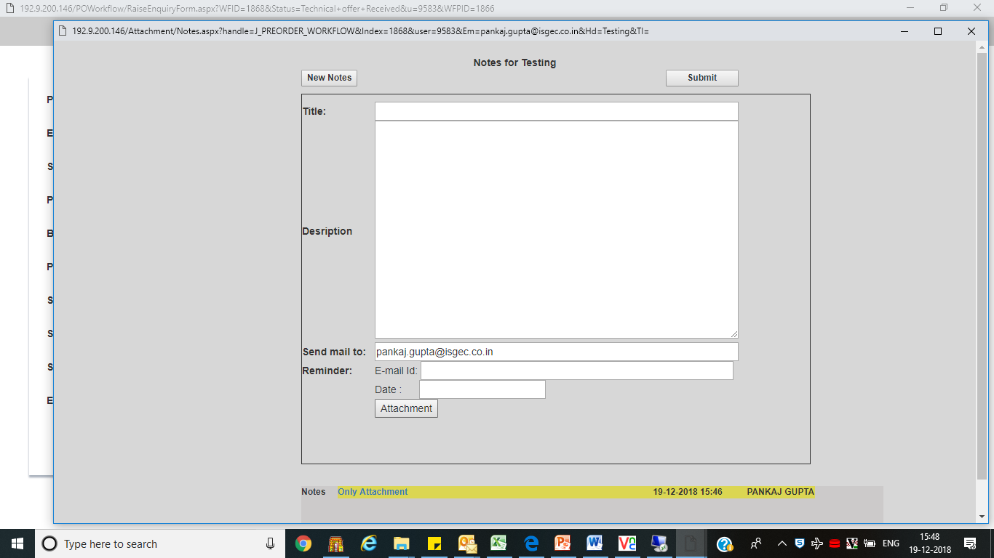
Enter the Title and content of email here
Click Here

- The following screen opens up Click in the Top Location First it will populate comments submitted by Engineering on IDMS Receipt, then select the required file to be sent to the vendor, then click on the below button and exit the session.
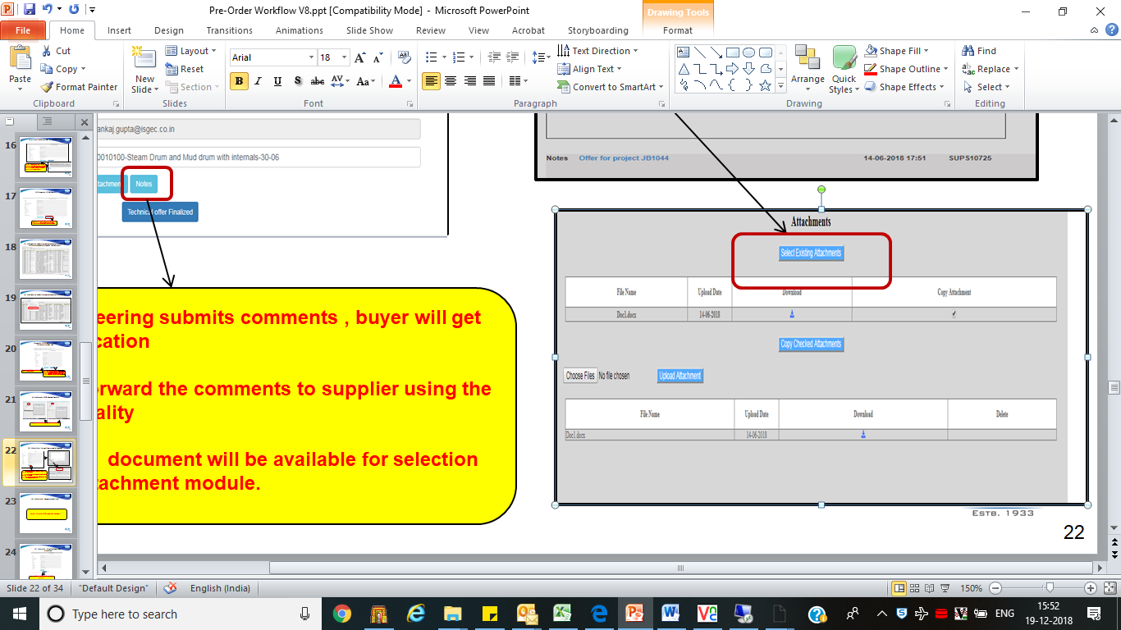
Then Click the Bellow Button
Click Here in Top Location

- In the screen that opens up click on Submit .
Submit

- This process will be repetitive till the time offer is not Technically cleared by Engineering .

- For Technical clearance Design Engineer will log in to session and clear as shown thru process option in specific.
An Email Alert will be sent to the Buyer
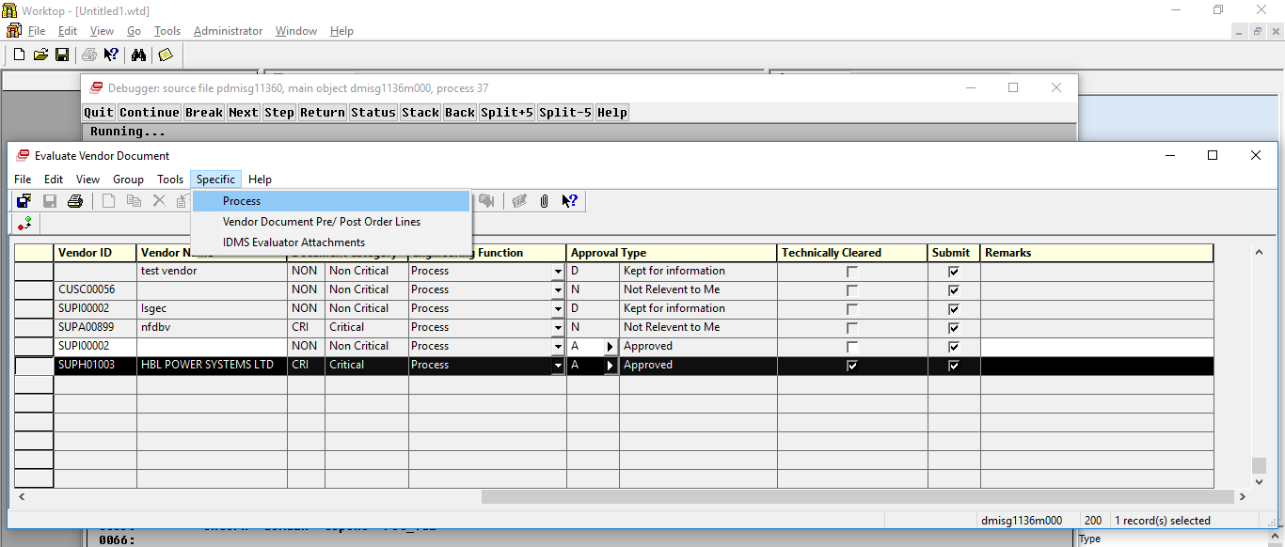.
Process

